**Week 2**

**Exercise 1: Setting Up JUnit**

**New Java Project**

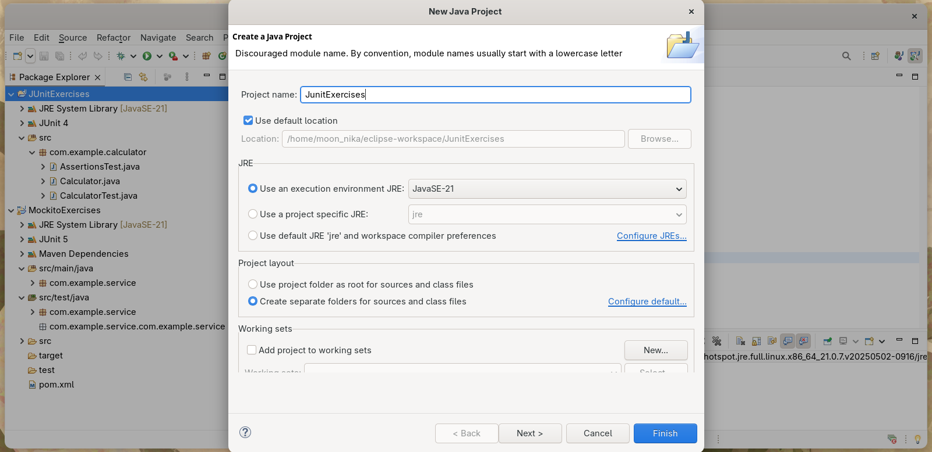

**pom.xml**

<project xmlns="http://maven.apache.org/POM/4.0.0"

xmlns:xsi="http://www.w3.org/2001/XMLSchema-instance"

xsi:schemaLocation="http://maven.apache.org/POM/4.0.0 https://maven.apache.org/xsd/maven-4.0.0.xsd">

<modelVersion>4.0.0</modelVersion>

<groupId>MockitoExercises</groupId>

<artifactId>MockitoExercises</artifactId>

<version>0.0.1-SNAPSHOT</version>

<dependencies>

<!-- Mockito -->

<dependency>

<groupId>org.mockito</groupId>

<artifactId>mockito-core</artifactId>

<version>5.11.0</version>

<scope>test</scope>

</dependency>

<!-- JUnit 5 -->

<dependency>

<groupId>org.junit.jupiter</groupId>

<artifactId>junit-jupiter</artifactId>

<version>5.10.0</version>

<scope>test</scope>

</dependency>

</dependencies>

<build>

<plugins>

<plugin>

<artifactId>maven-compiler-plugin</artifactId>

<version>3.13.0</version>

<configuration>

<release>21</release>

</configuration>

</plugin>

</plugins>

</build>

</project>

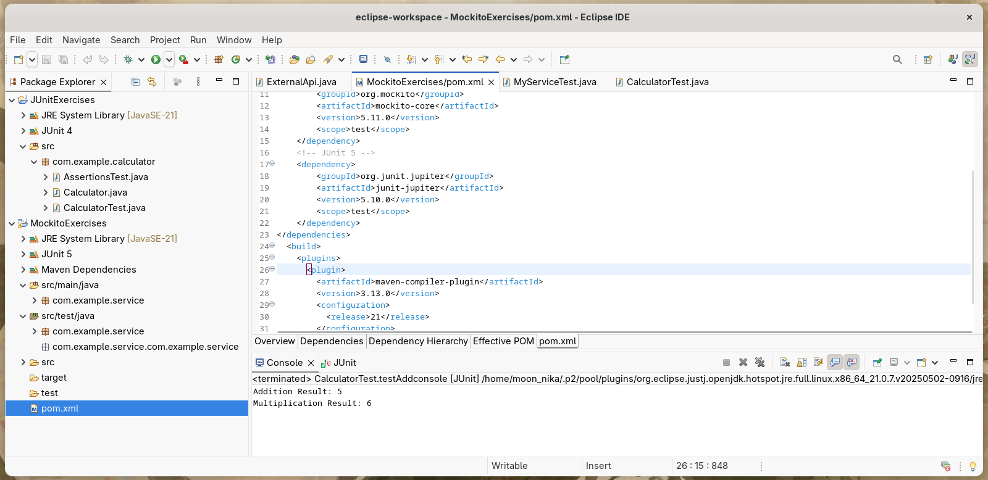

**New Test Class**

